**1.0 PROJECT INFORMATION**

|  |  |  |
| --- | --- | --- |
| PROJECT TITLE |  | |
| PROJECT DURATION |  | |
| PROJECT TYPE | Mini R&D | |
| COMPANY NAME |  |  |
| COUNTRY | Israel | Singapore |
| INDIVIDUAL PROJECT COST (US$) |  |  |
| TOTAL PROJECT COST (US$) |  | |

**2.0 COMPANY INFORMATION**

|  |  |  |
| --- | --- | --- |
| COMPANY NAME |  |  |
| COUNTRY | Israel | Singapore |
| YEAR ESTABLISHED |  |  |
| CORE COMPETENCIES |  |  |
| MAIN PRODUCTS  /TECHNOLOGIES |  |  |
| CUSTOMERS  *(****This section refers to paying customers only.***  *For companies – to indicate top 3 customers.*  *For RIs – to indicate top 3 licensees)* |  |  |
| TOP 3 R&D PARTNERS IN OTHER PROJECTS  *(Involvement in this project cannot be considered*  *For RIs/IHLs – to indicate partners in their industry R&D projects)* |  |  |
| REVENUES MOST RECENT FISCAL YEAR* (US$)  *(For companies, to refrain from including grants received*  *For RIs, to indicate revenues from licensing. Otherwise, to indicate research funding secured*    *Please include the audited financial reports of both applicants for the past 3 years in Appendix F)* |  |  |
| % REVENUES INCREASE / DECREASE OVER PREVIOUS YEAR |  |  |
| CURRENT NO. OF EMPLOYEES &  NO. OF R&D STAFF  *(Excluding personnel based in overseas offices)* |  |  |
| LOCATION OF OVERSEAS OFFICE |  |  |
| SHAREHOLDINGS BREAKDOWN  *(Top 5. State the shareholder’s name and number of shares (%) held)* |  |  |

**3.0 PROJECT ABSTRACT**

1. Describe the existing problem(s) in the target market that the proposed product is trying to solve.

2. Give a detailed description of the product’s functions/features and the way it works along with a description of the core IP that each company contributes to the proposed product.

3. Elaborate with schematic diagram(s).

4. Describe the technological gaps between the existing solutions/products that are being used to solve the problems listed in (1) and the proposed solution/product, highlighting the uniqueness or differentiation of the proposed product.

5. If the product is an improvement/upgrade from an existing product of the participating companies, describe the differences between the existing product and the proposed product.

6. Describe the competitive advantages and novelty of the proposed product as compared to other competing products and/or solutions.

**4.0 PROPOSED PROJECT PROGRAMME PLAN SUMMARY**

* + - 1. Provide a summary of the project programme plan in the suggested table format below.
      2. Refer to Appendix A to provide the detailed programme plan. Guidelines for the detailed programme plan are provided in Appendix A.

|  |  |
| --- | --- |
| **COMPANY** | **TASKS** |
| __________  *(Israeli Company)*  *(List the top 5 tasks for the project team)* |  |
| __________  *(Singapore Company)*  *(List the top 5 tasks for the project team)* |  |
| JOINT  *(List the main joint tasks of both companies)* |  |
| ISRAEL SUBCON /  CONSULTANT |  |
| SINGAPORE SUBCON /  CONSULTANT |  |
| BETA PARTNER  *(For planned beta trials, they must be included in the R&D programme plan in Appendix A. Written correspondence (email, LOI) from potential beta partners should also be included in Appendix A)* |  |

**5.0 TARGET MARKET AND COMMERCIALIZATION PLAN**

Describe the target market(s) of the proposed product and the commercialization plans in the suggested table format below.

|  |  |
| --- | --- |
| Target Market / Customers |  |
| Target Geographies |  |
| Potential Market (US$M) & Growth Potential (%)  *(Please include supporting information substantiating the information, e.g. 3rd party reports, in the Annexes section of the proposal. If there is existing interest in the product from potential customers, please also provide written proof in the Annexes section)* |  |
| Target Market Share (by year) |  |
| Proposed Commercialization Model  *(Including the detailed plans for the whole supply chain such as engaging the customer, mass production, delivery etc.)* |  |
| Role of _____________  in Commercialization  *(Israeli Company)* |  |
| Role of _____________  in Commercialization  *(Singapore Company)* |  |
| Planned Joint Commercialization Activities  *(With reference to activities, if any, indicated in category VIII of companies’ budgets)* |  |
| Proposed System and Pricing |  |
| Revenue Forecast /  Repayment Forecast  *(Please complete the revenue forecast table as stated in Appendix B)* | * Revenue forecast:  1. _______________estimates revenues of ___ in the first   *(Israeli Company)*  year (20_) and cumulative revenues of ___by the sixth year (20_)   1. _______________estimates revenues of ___ in the first   *(Singapore Company)*  year (20_) and cumulative revenues of ___by the sixth year (20_)   * Repayment forecast for proposed products:  1. _______________estimates to repay SIIRD within ___   *(Israeli Company)*  years of commercialization at a royalty repayment rate of ___%   1. _______________estimates to repay SIIRD within ___   *(Singapore Company)*  years of commercialization at a royalty repayment rate of ___% |
| Proposed Revenue Share Between Both Companies |  |
| Comparative Advantages Over Competitors  *(Please complete the competitor analysis as stated in Appendix C)* |  |

**6.0 PROJECT MANAGEMENT PLAN**

1. List all the project members, including their designation, and the respective consultants and subcontractors, and describe what their responsibilities in the project are.
2. Attach the resumes/CVs of all participating project personnel to Appendix D. The resumes/CVs should include the academic qualifications, work experience and skillsets/competencies of each personnel.
3. Describe the project management plan such as the frequency of meetings, the frequency of teleconferences, and the planning and reporting procedures, etc.

**7.0 PROJECT BUDGET**

Please prepare the Template for Project Budget & Financial Strength excel document for each company (template downloadable at <http://www.siird.com/guideline_forms_a.htm>) and attach them to the Appendix E. SIIRD does not fund any downstream cash requirements at the mass manufacturing stage. The guidelines for completing the Template for Project Budget & Financial Strength are found in the first worksheet of the spreadsheet.

**APPENDIX A – PROPOSED R&D PROGRAMME PLAN**

Discuss any challenges that might surface during the project. Highlight clearly the critical barriers to successful completion of the project, or commercialization of the proposed product.

1. Elaborate on the plans to overcome the challenges, technological gaps and barriers to success.
2. Please provide the Gantt chart of the project as part of Appendix A. The list of tasks in the Gantt chart must be consistent with the tasks listed in point 6 below. An example of a simple, yet satisfactory Gantt chart with respect to the required level of detail is illustrated below. Companies may also indicate in the Gantt chart the planned Joint Commercialization Activities during the project period.

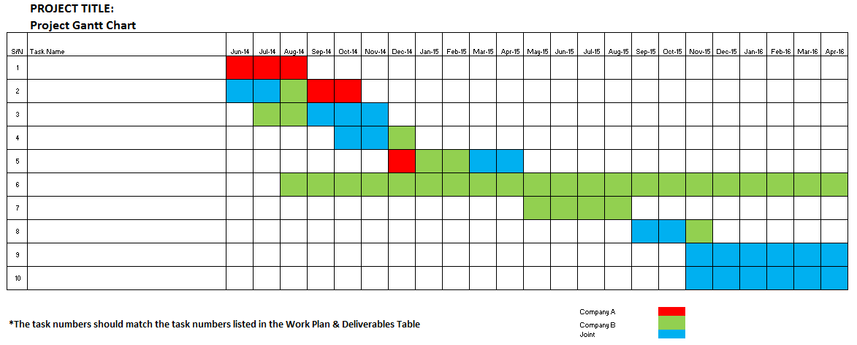

1. Attach any written correspondence from interested parties, who are keen to be beta trial partners, to Appendix A.
2. Explain if there are any certifications or regulatory standards required for the product or technology e.g. FDA or CE mark.
3. Using the suggested table format below, describe and indicate for up to 20 main tasks :

The work plan and deliverables of the project

The man months for each task

Whose responsibility it is to carry out each task. It should be split into different % contribution by various parties.

**NOTE: The Work Plan and Deliverables table as well as Tasks and Manpower Allocation table below shall correspond with the Gantt Chart and manpower allocation in the Project Budget.**

|  |  |  |  |  |  |  |  |  |  |
| --- | --- | --- | --- | --- | --- | --- | --- | --- | --- |
| **Work Plan and Deliverables** | | | | | **Tasks and Manpower Allocation** | | | | |
| **S/N** | **Task Name** | **Task Description (Detailed description of tasks activities, tests, measurements etc)** | **Deliverables/Milestones** | **Duration (months)** | **Man Months** | **Responsibility (%)** | | | |
| **Israeli**  **Partner** | **Singapore**  **Partner** | **Sub-Con/ Consultant of IL Partner** | **Sub-Con/ Consultant of SG Partner** |
|  |  |  |  |  |  |  |  |  |  |
|  |  |  |  |  |  |  |  |  |  |
|  |  |  |  |  |  |  |  |  |  |
|  |  |  |  |  |  |  |  |  |  |

**APPENDIX B – REVENUE FORECAST TABLE**

Please prepare the revenue forecast table for the proposed product(s) and attach it to Appendix B (<http://www.siird.com/guideline_forms_a.htm>).

**APPENDIX C – DETAILED COMPETITOR ANALYSIS**

Using the table template below, provide a comparison of the proposed product to the competitors’ products in terms of performance (functions, features etc.) and price.

|  |  |  |  |  |  |
| --- | --- | --- | --- | --- | --- |
| Competitors | Country | Name of Product | Price (US$) | Market Share (%) | Strength/Weakness |
|  |  |  |  |  |  |
|  |  |  |  |  |  |
|  |  |  |  |  |  |
|  |  |  |  |  |  |
|  |  |  |  |  |  |
|  |  |  |  |  |  |

**APPENDIX D – RESUMES/CVs OF PARTICIPATING PERSONNEL**

Attach the resumes/CVs of participating personnel to this Appendix.

**APPENDIX E – PROJECT BUDGET**

Attach the Project Budget of each company to this Appendix.

**APPENDIX F – AUDITED FINANCIAL REPORTS OF COMPANIES**

1. Attach the following to this Appendix:
   1. Audited financial reports of the last three years for each company
   2. ACRA profile of Singapore company
   3. Israeli Corporations Authority profile of Israel company

**ANNEXES**

*Last Updated: Jan 2018*